Project 1:Mastermind

Class: CSC-5 41202

Name: Kayla Rodriguez

Date: 02/02/2016

Introduction

Title: Mastermind

Mastermind is a code breaking game for users to try and guess four different colors the computer picked by random. The user uses hints given by the computer telling them whether their color is in the right spot, or how many of the colors are correct. The user inputs how any attempts they are willing to play, and to win they must guess the correct colors before 10 tries.

Project Description:

This project illustrates the different constructs and data types learned in class.

Size: 320 lines

Concepts Utilized:

* Character data types
* Integer data types
* Float data types
* Boolean data types
* Ternary operators
* Single if-else statements
* Expanded if-else statements (if, else if, else)
* Formatting (setting the precision of a decimal)
* Single if
* Switch decision
* While loops
* Do-while loops
* For loops
* File (opening a file containing the outputted results)
* Random number seed

Variables Used, Types and Descriptions

|  |  |  |
| --- | --- | --- |
| Type | Variable Name | Description |
| char | pick1 | First pick of computer |
| char | pick2 | Second pick of computer |
| char | pick3 | Third pick of computer |
| char | pick4 | Fourth pick of computer |
| char | color1 | First color pick of the user |
| char | color2 | Second color pick of the user |
| char | color3 | Third color pick of the user |
| char | color4 | Fourth color pick of the user |
| char | hint | Hint to display correct color choices |
| int | limit | Maximum attempts the user wants to try the game |
| int | nTrys=0 | Counter variable used to count the number of attempts of the user |
| const char | GMELMT=10 | Game limit, you can only win if you can guess under 10 tries |
| bool | hintR=true | Boolean variable used to repeat the hints after each turn |
| ofstream | out | Produces output into a file |

Pseudo Code

Initialize

Introduction to Game

Computer Generated Pick

Generates random variables for the user to pick (do-while loops used)

Input

User inputs their first color choices, if user picks an option unavailable, displays message again

Counter Initialized

Counts how many tries it takes the user to guess the winning colors or up until the limit

Hints Displayed

User presses one to see hints for all of their picks (how many are in the right spot and how many are correct but not in the right spot).

Default: No hints displayed

Hints displayed after each new guess

Counter Initialized

Displays to the user what attempt they are on

Displays after each new guess

Outputs Result

Reveals to the user the computer’s choice

If the user can guess in below 10 tries, they won and output displays message that they won and the percentage of the board they took up.

Else displays lose message

End

Flowcharts

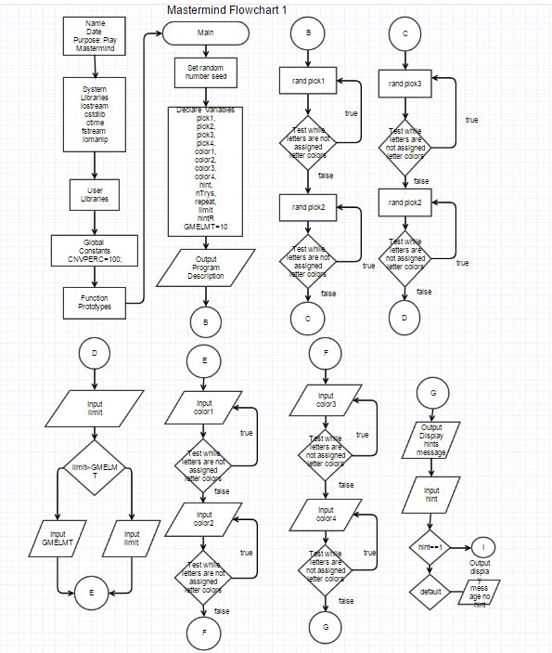

Flowchart of If-Else Decision Statements

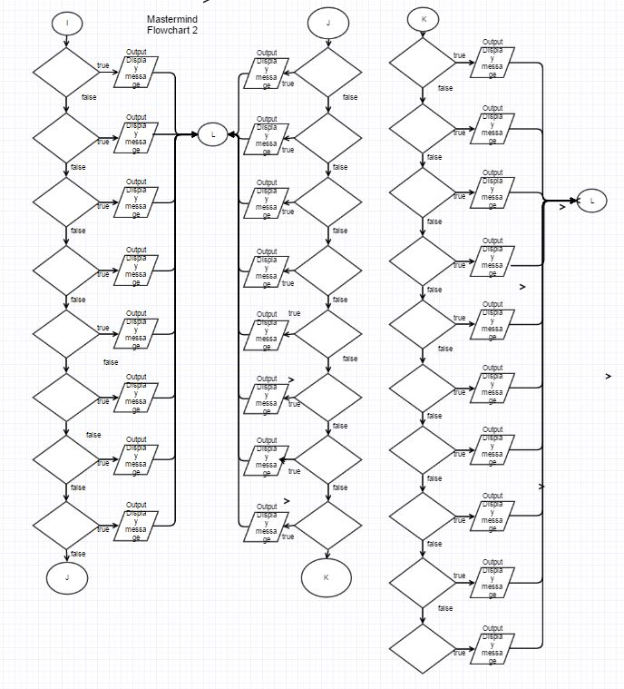

(decisions too long to fit in diamonds)

